**Study on the Hydrogenation of a Mm-based AB5-Intermetallic for Sustainable Building Applications**

Evangelos I. Gkanas* and Martin Khzouz

*Hydrogen for Mobility Lab, Materials and Processes for Energy Needs, Institute for Future Transport and Cities, Coventry University, CV1 2TL, Coventry, UK.*

*\*Email: ac1029@coventry.ac.uk*

**Abstract**

In the present study, a numerical approach regarding the thermal management of a Mm-based AB5-intermetallic (MmNi4.6Al0.4) for the hydrogenation processis introduced and analysed. Several heat management scenarios are studied. The numerical model was supported and validated with experimental data in terms of hydrogenation capacity and temperature distribution. The numerical analysis is based on the introduction of the energy, mass and momentum conservation equations to numerically describe the hydrogenation reaction. The main aim of the present study is the numerical description of the heat management when 200 g of hydrogen are stored (13 kg of the hydride). The heat management cases consider the usage of cooling tubes in combination with high thermal conductivity fins. In general, various parameters affect the efficiency of the heat management. The parameters considered are the fin thickness, the fin number - which is directly connected to the metal hydride thickness convective heat transfer coefficient. A non-dimensional parameter (NDC) specially modified to describe the role of the fins in addition to the cooling tubes is introduced to evaluate the heat management. The target of the study was to reduce the hydrogenation time of almost 13 kg of MmNi4.6Al0.4 and from the parametric study it has been found that the more efficient conditions are fin thickness between 5-8 mm and the convective heat transfer coefficient of 2000 W/m2K.

***Keywords****: Mm-based Intermetallics, Stationary Hydrogen Storage, Non-Dimensional Conductance, Effective Heat Management*

1. Introduction

While buildings provide benefits and development to humanity, they also introduce significant environmental and health impacts [1]. At the moment, the building sector contributes to more than 35% of the global energy consumption and more than 40% of direct and indirect CO2 emissions [2, 3]. Furthermore, the construction of new buildings and the renovation of old ones utilises natural resources, from raw materials to non-friendly environmental processes [4, 5]. The development of non-renewable processes, such as non-efficient Heating, Ventilation and Air-Conditioning (HVAC) can equally affect the environment in the long-term [6] in addition to the usage of non-renewable materials for the buildings. It has also been reported that the energy consumption in the most advanced cities (and countries) around the world has gone beyond the correspondent consumption of the industrial and automotive sector [7, 8]. In addition, it is expected that over the next 20 years, more than two-thirds of the new buildings will occur in countries that lack of building energy codes [9]. Consequently, as a matter of urgency there is need for energy efficient buildings that will be environmental friendly, with the lowest possible levels of greenhouse gas emissions [10, 11]. A green and sustainable building is defined as an environmentally friendly and responsible structure which is also resource-efficient for the building life-cycle [12, 13]. The utilization of hydrogen fuel cell technologies for sustainable building applications is a potential way to deal with the large amount of CO2 emissions [14]. Fuel Cells (FCs) are suited for utilization within micro Combined Heat and Power (CHP) applications in buildings [15]. The main reason is that FC systems have an advantage over conventional CHP systems in terms of lower heat to power ratios [16, 17]. One of the major issues for the introduction of FC technologies in the market is the storage of hydrogen [18, 19], along with sustainable hydrogen production [20]. The current technologies for hydrogen storage are: high pressure gas storage, liquid storage and solid-state storage accompanied by the formation of metal hydrides [21]. Amongst those technologies, the solid-state hydrogen storage presents the less disadvantages as compared with the hydrogen storage technology as compressed gas and liquid hydrogen [22], as hydrogen can be effectively store at moderate pressure and temperature conditions [23, 24]. The solid-state hydrogen storage is a complex process, as it involves several physical processes, such as diffusion, chemical bonding and heat transfer [25, 26]. There are various parameters affecting the thermodynamics of the metal hydrides [27, 28], such as the hydrides thermal conductivity, the heat capacity, as well as the enthalpy and entropy change during the hydride formation/deformation [29]. Some other parameters regarding the hydride tank design, such as the bed geometry, the heat management, the overall heat transfer coefficient, the overall beds thermal resistance and the packing conditions are also very important and crucial for the effective hydrogen storage/release that must be considered when designing a metal hydride storage system [30, 31]. Finally, for the storage of the maximum possible amount of hydrogen at low-pressure beds several parameters are crucial, such as grinding alloys, the reduction of oxygen poisoning tendency and the cycling performance [32].

One of the major limiting factors for the hydrogen storage/release is the rate the heat is supplied and removed to and from the hydride tank. During the storage of hydrogen within the hydride tank, atomic hydrogen forms bonds with the metal lattice, leading to an exothermic reaction [33, 34]. Because of the exothermic nature of the process, the temperature of the hydride increases leading the equilibrium pressure to increase as well [35]. As a result, the kinetics for hydrogen storage will decrease [36]. On the other hand, the dissolution of the hydride bonds is an endothermic process, as large amounts of thermal energy are necessary [37].The utilisation of a thermal management mechanism that would be able to remove effectively the produced amount of heat from the tank during the hydrogenation is necessary for balancing the driving force for the hydrogen storage/release [38]. In general, the thermal management of hydride vessels can be applied either internally or externally [39]. There are three major techniques for the enhancement of the heat transfer to/from a hydride bed [40]. The metal hydride thickness can be decreased [41], the total system’s thermal conductivity can be increased [42] and as per Fourier’s law of conduction, the introduction of a temperature difference in the system [43, 44].

In the past, there has been an extensive research in the field of thermal management of metal hydride tanks, in order to enhance the reaction kinetics of the hydrogenation/dehydrogenation and to optimise the tank design.

Two AB5-intermetallics, MmNi4.6Fe0.4 and MmNi4.6FAl0.4 were experimentally studied as potential materials for hydrogen storage [45]. The study majorly focused on the effect that the supply pressure, the hydrogenation temperature and the bed’s overall heat transfer coefficient on the hydrogenation of the two materials. The overall heat transfer coefficient was found to have a negligible effect on the hydrogen storage capacity, but affected the hydrogenation kinetics. The geometry used includes 8 radial fins made of cooper to enhance the effective thermal conductivity and the activation process was also presented. The overall heat transfer coefficient in that study varied from 750 to 1250 W/m2K.

In another study, Ti1.1CrMn utilised to investigate the hydrogen storage for hydrogen fuel cell cars [46]. A high-pressure metal hydride system (a system which is a combination of high-pressure tanks with absorbing alloys at high pressures) was utilised and the geometry consists of co-central heating/cooling tubes with the incorporation of Al fins. The metal hydride bed was modelled as a zero-dimensional system by a lumped mass approximation. In this study, the heat transfer coefficient inside the cooling/heating tubes has been provided by the utilization of the Nusselt number correlations [47] and an approximate overall heat transfer coefficient for the whole system (cooling/heating tubes, fins and the material) has been derived using suitable approximations. Three main parameters were examined, the bed temperature, the coolant’s temperature and the coolant’s flowrate.

In addition, three different shell designs have been introduced and examined [48]. The first geometry the metal hydride is placed within a shell and the cooling/heating fluid flows through tubes which are interconnected with conducting fins. The second geometry, helical tubes where the cooling/heating fluid flows were selected, whereas for the third design, the metal hydride has been placed in the tubes and the fluid flows via the shell. The material used as a reference is sodium alanate. The optimization factors introduced in this study are the diameter of the bed, the fin thickness, the placement of the cooling tubes and the diameter of the tubes. It was concluded that the most effective geometry is the utilization of a helical heat exchanger, as it is characterized by high heat transfer coefficient resulting from the flow turbulence.

Another approach was focused on the hydrogenation process of 1 kg of LaNi5 both experimentally and theoretically when using a storage device with embedded heat exchangers [49]. The geometry examined was cylindrical, with the central tube to be enhanced with 13 radial/circular copper fins. The fins were selected to be perforated, in order to reduce the total weight of the system. The performance analysis was focused on the effect that the number of fins, the fin thickness, the fin perforation, hydrogen supply pressure and the water (cooling fluid) temperature and velocity on the hydrogenation of the hydride.

Several cooling designs for a LaNi5 metal hydride tank were also presented [50], where a 2D numerical model developed and experimentally validated. A co-centric heat exchanger tube equipped with extended surfaces was introduced, studied and compared with various geometries from the literature. The main parameter examined was the fin diameter and it was found that optimization can occur up to 80% enhancement of the performance. In addition, the effect of steel and brass walls in the hydrogenation process was studied.

An experimental study considering LmNi4.91Sn0.15 as the operating hydride, under several conditions regarding the hydrogen supply pressure, hydrogenation temperature and cooling fluid flow rates has been performed for the enhancement of the heat transfer rate [51]. Two different geometries have been built with different number of embedded cooling tubes. The number of the tubes was 36 and 60, employing the hydrogenation process of 2.75 kg of material. In addition, two fluids were used for the heat exchange; water and oil. The results showed that both the working fluids could directly and efficient remove the heat produced during the hydrogenation.

In another experimental study [52], LaNi5 was utilized as the working material by considering two main geometries, a ‘conventional’ one where the water circulates and removes the produced heat and a second with a finned tube heat exchanger. The fins were made of stainless steel and at both reactors the amount of the hydride was 1 kg. The operational parameters examined were the mass flowrate of the cooling fluid, the temperature of the cooling fluid and the applied hydrogen pressure to bed. It is concluded that the design parameters such as the heat exchanger, the filters and the distribution of the alloy in the system can play crucial role in the kinetics of the hydrogenation.

In a theoretical work, an optimization of a finned multi-tubular geometry has been investigated [53]. Various parameters regarding the fins have been examined; the fin radius, the fin thickness and the fin number. It has been highlighted that the overall thermal resistance of the storage system reduces with the increase of the fin radius, thickness and number. In addition, it has been outlined that the fin number has the most significant effect in the reduction of the hydrogenation time. LaNi5 was utilized as the working hydride for the simulation purposes.

The importance of the development of a valid heat management strategy for industrial-scale hydrogen containers has also been highlighted [54]. For that reason, a validated 2D mathematical model for the prediction of hydrogen storage with MmNi4.6Al0.4 as the working hydride in cylindrical tubes was introduced with various number of embedded cooling tubes. The cooling tubes were placed co-centrally in the metal hydride bed and 12, 14, 16, 18 and 20 tubes were examined. The convective heat transfer coefficient in this study was kept constant at 1000 W/m2K. It has been concluded that the optimum geometry was the one that included 20 cooling tubes and at the same time an outer cooling jacket was utilized. In addition, with that optimum geometry, other parameters were investigated, such as the hydrogen supply pressure, cooling fluid temperature and the overall heat transfer coefficient. For that system, the optimum values were found to be 30 bar, 20 oC and 1250 W/m2K.

An alternative way for heat management is the introduction of Phase Change Materials in the metal hydride tank that are able to store the produced thermal energy during the hydrogenation and release it for the dehydrogenation which is a purely endothermic process [55]. The usage of PCM in a metal hydride reactor when LaNi5 is used as the working material is described in a transient 2D numerical approach and the results revealed that the region close to the PCM can complete the absorption on a faster pace as compared to the core of the reactor.

The heat management is also very crucial to the high-temperature hydrides, such as MgH2. For MgH2 the large amounts of heat during the storage/release are affecting the reaction, thus the usage of extended surfaces and helical coil heat exchanger has been proposed [56]. Three geometries have been proposed, studied and compared to each other in terms of reaction kinetics. The first geometry is a straight tube heat exchanger, the second is a finned tube heat exchanger and the last one is a helical coil heat exchanger. The effects of key parameters such as initial hydrogen pressure, temperature and overall heat transfer coefficient were analysed.

A 3D-theoretical model that describes the hydrogenation behavior of MmNi4.6Fe0.4 when 8 copper fins were added on the co-central cooling tube was studied [57]. The effect of various parameters such as length, thickness and the thermal conductivity of fins, as well as the overall heat transfer coefficient on the reaction kinetics was studied. The outcomes of that study showed that the usage of fins enhances the heat transfer rate and is capable to improve by 40% the reaction time as compared to the case without the usage of fins.

A novel approach by the introduction of finned spiral tube heat exchangers has been presented for effective solid-state hydrogen storage for fuel cell vehicles [58]. The 2D validated numerical study mainly focused on several parameters such as the pitch, the length, the thickness and the fin arrangement in terms of their influence in the hydrogen storage of LaNi5. The outcomes of this study revealed that the circular fins on the system has the capability to enhance by 66% the hydrogenation time as compared with the case without fins.

A 2D transient model was introduced to study the effect of the usage of external fins, in order the hydride to deliver hydrogen at a constant flowrate when the metal hydride used was LaNi5 [59]. The study considered two cases; the first case is a cylindrical metal hydride tank without the fins and the second one is the cylindrical tank with the presence of external fins. In that study, the comparison between the two cases was made by the investigation of the internal gas (hydrogen) pressure and temperature behavior during cycling. The preliminary resistive analysis outcome was that the addition of external fins can have a significant impact on the overall heat transfer and would positively affect the reaction kinetics.

A large-scale hydrogen storage system for the hydrogenation process of 210 kg of Hydralloy C5 (Ti-Mn based) has been presented [60]. The main concern for considering this study was the large-scale solid-state hydrogen storage systems are creating hot-spots, as well as parasitic system weight and the authors tried to answer the question of the most effective heat transfer enhancements. The reactor dimensions have selected to be radius of 0.1524 m and height of 1.047 m. The main result of the study is that an optimum geometry was found to include 14 cooling tubes where a gravimetric capacity of 0.7% could be reached in 15 min.

The usage of fins in both longitudinal and transverse positioning has been studied on a 2D axi-symmetric model to describe the hydrogenation reaction of sodium alanate. The amount of hydrogen stored in the system was 1 kg; thus, the amount of the material was selected to be 126 kg [61]. They have found that although the utilization of the fins significantly reduced the sorption kinetics, to achieve the DOE targets the kinetics must reduce even more by a factor of three. The authors suggested the supply pressure increase and the development of catalysts that will accelerate the reaction.

In another study [62] an experimental investigation of a Ti-Fe based metal hydride has been performed, where the effects of the metal hydride bed in the hydrogenation/dehydrogenation was examined. The reactors examined were a ‘simple’ tubular reactor, tubular reactor equipped with fins and finally the usage of liquid cooling channels for the heat removal. At several spots within the metal hydride tanks, the temperature was obtained and compared to the different cases. It has been extracted that the design of the reactor together with the activation process of the material are crucial factors to reduce the charging time. A reduction of 84% in the charging time and almost 40% faster charging rate was reported when the third reactor was used instead of the first one.

A semi-analytical expression of the heat transfer rate from a single fin has been introduced and presented [63]. The effects of the fin geometry, mainly the fin thickness and the radius on the hydrogenation process were identified. A very interesting outcome was that for the same fin volume, the increase of the fin radius and the decrease on the fin thickness could decrease the thermal resistance of the whole heat exchanger. In addition, on the second part of the study, the authors presented a 2D numerical simulation on the hydrogenation of 1 kg of LaNi5 powder to validate the results from the previous analytic study. Two parameters were highlighted; the diameter of the cooling tube and the fin length. It has been found that the increase of the increase of the fin diameter by 2, can result to 25% reduction of the charging time. At the same time, the increase of the fin length could result in the decrease of the thermal resistance by 13% leading to a lower charging time by 42%.

It is apparent from the previous analysis that there has been high quality research and understanding on the thermal management of metal hydride tanks in the past. Although, the quantitative analysis and evaluation of the outcomes of the thermal management on the hydrogenation/dehydrogenation kinetics is quite limited. In almost all the previous studies, the parametric study for the fin number, fin thickness, fin diameter and all the rest studied parameters has been performed by the comparison of the hydrogenation/dehydrogenation kinetics under the different scenarios. One of the main targets and the novelty of the current work is the introduction of a quantitative way to compare the outcomes of the parametric study of the thermal management when extended surfaces are introduced in the system. In addition, the lion’s share of the research so far is mainly focused on relatively small-scale systems of hydrides (maximum up to 1 kg of material). In the present study, the numerical description of a relatively large-scale analysis (13 kg of material) is performed and discussed. Another novelty of the current work is the introduction of an expression for the heat transfer coefficient, by utilizing the heat produced/consumed and the average temperature of the tank walls and the metal hydride. Finally, the thermal conductivity of the materials was calculated by incorporating the Zehner, Bauer and Schlunder method and considering the Knudsen effect. The working material used in this study was a AB5-intermtallic (MmNi4.6Al0.4). The main reason for choosing this alloy is the ease of synthesis and production in large quantities, as well as the flat plateau and low hysteresis that present during charging/discharging. The aim of this work is the enhancement of the heat transfer from the hydride tank when 200 g of hydrogen are stored by the combination of cooling tubes with extended surfaces that will introduce a temperature difference within the bed (tubes), whereas at the same time will increase the total thermal conductivity of the system (fins) and the introduction of a quantitative analysis to effectively describe the effect of the thermal management system to the hydrogenation/dehydrogenation kinetics of the metal hydride via a non-dimensional parameter; the Non-Dimensional Conductance (NDC). The numerical approach is based on the introduction of the unsteady heat and mass transfer conservation equations together with the energy equation. The MmNi4.6Al0.4 intermetallic was synthesized and tested in order to extract important parameters, such as the enthalpy and entropy change during the reaction (ΔΗ and ΔS), the plateau slope and hysteresis, as well as the specific heat capacity and the thermal conductivity. The numerical model was supported and validated against solid experimental results in terms of hydrogenation capacity over time (hydrogenation kinetics) and temperature distribution. The metal hydride beds have cylindrical shape with the properties of stainless steel (SS 316L). The parameters considered for the study are the fin thickness (*fth*), the fin number (*fn*) and the convective heat transfer coefficient (*ht*). The thermal conductivity of the material was updated in the model by incorporating the Zehner, Bauer and Schlunder method by also considering the Knudsen effect.

**2. Numerical Model**

***2.1 Assumptions considered for the model formulation***

The process of hydrogen storage with the accompanied metal hydride formation is a rather complex process, as it involves chemical reactions as well as heat and mass transport phenomena. Thus, the following assumptions have been considered;

1. At the beginning of the hydrogen storage both the temperature and pressure profiles are uniform.
2. Thermodynamic properties, like the specific heat capacity for the solid and the gas state is constant.
3. The system is in local thermal equilibrium between gas and solid.
4. The bed void fraction is constant and uniform
5. The packing conditions are perfect and the contact resistance between the hydride and the cooling tubes is minimum.
6. Heat transfer by radiation is negligible.
   * 1. ***Energy equation***

The importance of assumption c) is that one single combined thermal energy equation is introduced and solved instead of two individual equations for the material and hydrogen. The combined energy equation is updated from the following expression.

 (1)

The term *m (kg/s m3)* is the hydrogenation kinetic term and will be further analysed at section 2.1.4.

The heat capacity for the combined system is updated by;

 (2)

Where *ε* is the materials porosity, *ρg* and *ρs* [kg/m3] is the hydrogen density and the solids density respectively and *Cpg* and*Cps* is the heat capacity of hydrogen and the material.In the current study, the effective thermal conductivity is updated by introducing the Zehner, Bauer and Schlunder method. This method can be used for the prediction of the thermal conductivity of packed beds [64]. The data form [65] were fitted to the following equation:

 (3)

Where *C0*, *C1* and *C2* are fitting coefficients.

* + 1. ***Hydrogen and Solid Mass Balance***

The continuity equation is used to update the hydrogen mass balance:

 (4)

The positive sign on the right hand site is referring to the dehydrogenation process, while the negative to the hydrogenation. The gas velocity is given by *vg (m/s)* and is described in the following part, whereas the term Q is the volumetric hydrogen amount.

For the solid phase (metal/hydride) the mass balance equation is given from:

(5)

* + 1. ***Momentum equation***

The fluid flow via porous mediums is described by Darcy’s law. If the gravity term is neglected, then a proportional relationship arise and is given by:

 (6)

The solid permeability is given by *K (m2)* and the gas dynamic viscosity by *μg (Pa s)*. The hydrogen pressure is updated by *Pg (Pa).* The Kozeny-Carman approach is used for the calculation of the permeability:

 (7)

***2.1.4 Hydrogenation Kinetics***

The term *m* that has been introduced in Eq (1) represents the hydrogenation rate and is updated from the following expression [65]:

 (8)

Where *ρs*represents the hydride’s density at any time during the hydrogenation during and *ρss* is the hydride’s density when the hydrogenation ends. The term *Ca* *(1/s)* refers to a pre-exponential constant and the *Ea* *(J mol-1)* refers to the energy for the activated process. Both of those two parameters must be calculated from experimental data extracted from the isothermal measurements and then to incorporated to the equations.

* + 1. ***Equilibrium Pressure.***

The hydride equilibrium pressure is estimated by introducing the van’t Hoff equation as follows [66]:

 (9)

In Eq (9) the plateau slope and hysteresis are considered, as both factors are crucial for the hydrogenation. The slope at the plateau is updated by the terms *φs*and *φ0* (measured experimentally) and the term *S* introduces the hysteresis given by (*lnPabs/Pdes*). The hydride concentration and the saturation concentration are updated by *x* and *xsat* respectively.

* + 1. ***Initial and Boundary Conditions***

At the beginning of the hydrogenation (assumed as *t=0 s*), the hydride’s temperature, pressure and density are assumed uniform. Thus, the initial conditions are listed as follows:

*Tin=T0=20 oC; Pin=P0=12 bar and ρin=ρ0=4200 kg/m3* (10)

The upper/lower walls of the storage bed are assumed as adiabatic, non-slip condition is valid at the heat exchanger tube walls. Thus, the boundary conditions are the following:

$\left(-k∙∇T\right)∙\vec{n}=0$ (11)

$\left(-k∙∇T\right)∙\vec{n}=h∙(T_{fluid}-T)$ (12)

1. **Methodology**

A multiphysics software (COMSOL Multiphysics 5.3®) was utilised to introduce and solve simultaneously the conservation equations. The model was validated and supported against solid experimental data of temperature and hydrogenation capacity. The data were extracted from a commercial Sievert apparatus (Hidden Isochema). It is also known that during the hydrogen storage, a volume expansion up to 30% occurs. The expansion results on additional stresses to the tank walls. Thus, the tanks were assumed 50% full as compared to their maximum active volume at the beginning of the hydrogenation. Then, a parametric study on the thermal management of the bed takes place. The fin thickness (*fth*), the fin number (*fn*) and the convective heat transfer coefficient (*ht*) are the parameters considered. Finally, a modified version of the Non-Dimensional Conductance (NDC) reported in [24, 43], specially designed for the effect of extended surfaces is utilised for the assessment of the heat management.

**3.1 Numerical Model Validation**

For the validation of the proposed numerical model, solid experimental data were extracted for the synthesised intermetallic by using a lab-scale Sievert-type apparatus. The material has been synthesised by arc-melting. The ingots were turned at least 5 times to ensure the homogeneity of the samples. Sensible ball milling utilised to achieve fine powder. A quantity of 0.9 g was tested regarding the hydrogen storage properties in a commercial lab-scale Sievert-type apparatus (Hidden Isochema). The activation process for every material to be used for solid-state hydrogen storage is a crucial process that will allow to remove the oxide layers that are present in the surface of the material and act as the barriers for the hydrogen diffusion to the core of the hydride and at the same time due to the stresses and the lattice defects that are present during the first charging/discharging cycles are acting as effective pathways for the hydrogen diffusion [67]. In the present work, the synthesised Mm-based alloy was activated at high pressure and almost room temperature. Initially, the sample was evacuated to 10-6 bar. The system was flushed three times to remove any other gas traces. Then, high pressure hydrogen gas (80 bar) at 27 oC and kept until the sample reached the equilibrium. Then, the reactor was heated up to 80 oC and allowed hydrogen to be released. This process was repeated up to 5 times until the hydrogenation capacity to stabilise at 1.45 wt%. In addition, the thermal conductivity and density of both the bulk materials (just after the synthesis) and the powders (after sensible ball milling) were measured. The density was measured by using a commercial gas displacement pycnometry system (Micrometrics Accupycn1340). The thermal conductivity was obtained by using a TCI thermal conductivity analyser (C-therm technologies). Prior and after the hydrogenation measurements, the phase purity was investigated by means of X-ray diffractometric in addition with Rietvelt refinement. The PcT isotherms were obtained at various temperatures (at least three) to plot the van’t Hoff diagram. From the diagram (slope and intercept with y-axis) the enthalpy and entropy difference were calculated. For the recording of the temperature during the hydrogenation, a K-type thermocouple was placed inside the sample. The supply pressure for the experimental validation was 12 bar. The geometry of the experimental reactor is described in detail in [44]. The validation is shown in Fig. 1. Fig. 1a shows the comparison between the experimental temperature distribution (dashed line) and the temperature distribution extracted from the numerical results (bulk line) and Fig. 1b presents the comparison for the hydrogenation capacity.

***Fig. 1. Comparison between the proposed numerical model and the experimental data. Fig. 1a shows the comparison between the temperature profile and Fig. 1b the comparison for the hydrogenation capacity***

* 1. **Tank Design Geometries**

The shape of the tanks in this study is cylindrical. The wall thickness was 3mm, similar to commercial available tanks. In addition, the tank was selected to occupy the properties of stainless steel SS 316L. The amount of hydrogen stored per cycle was 200 g and for that reason the amount of material introduced to the study was close to 13 kg. The dimensions of the tank were 0.8 m length with internal radius of 0.052 m. The heat management in the current work was focused on the combination of plain-embedded cooling tubes (convective heat transfer) with extended surfaces (conductive heat transfer). Fig. 2 presents the geometry of the fins used (up) and the final configuration of the tubes as combined with the fins (down). Four cooling tubes were placed on a co-central configuration around the central tube. The fins include several openings. First, there are five cylindrical openings that allow the cooling tubes to be in contact with the fins. Secondly, there are four extra openings. The selection of the extra openings was made to serve three important purposes. The first is due to packing reasons; the powder during the filling has to be distributed evenly and more importantly, the maximum possible contact of the powder with the cooling tubes and the fins must be ensured. The second is related to the expansion that occurs during the hydrogenation and the final one is regarding the systems total weight reduction.

***Fig.2 Fin geometry (up) and the complete assembly of the fins, the cooling tubes and the complete metal hydride tank used in this study (down).***

**3.2.1 Optimisation Factors and Control Parameters**

The hydrogenation kinetics are a very important aspect for the effective hydrogen storage. The kinetics can be described by the charging time *ts*. In the present work, the optimum conditions to achieve the minimum possible charging time for the MmNi4.6Al0.4 were obtained. The charging time in the current study is considered as the necessary time to increase the hydrogenation fraction X from 10% to 90%. Hydrogenation fraction X is the ratio between the amounts of hydrogen stored to the maximum theoretical amount of hydrogen that the material can store. For that reason, the study includes the investigation of the following parameters: fin thickness *fth*, find number *fn* and heat transfer coefficient *ht*. For the coolant, water has been selected to flow through the tubes, as the cooling temperature has been selected to be 20 oC. For the convective heat transfer coefficient, four different values have been selected (500-1000-2000 and 5000 W/m2K). By definition, convection takes place when thermal energy is transferred between a surface (in this case the surface of the tube) and a moving fluid (water) that have different temperatures. By applying the Newton’s Law of cooling (*q=h ΔΤ*), where *h* is the convective heat transfer coefficient (W/m2K), the convective heat transfer coefficient is affected by the fluid’s physical properties and the physical situation. It has to be mentioned that h is not a fluids property but an experimental extracted parameter that the values depend upon the geometry of the surface, the fluids motion nature and the fluid’s natural properties. For the case of forced convection, that is been achieved when the coolant within the pipe is induced by an external force (in the current case for such a system will be a pump) the heat transfer coefficient for water and liquids can take values from 50-10000 W/m2K. To increase the convective heat transfer coefficient in the pipe with diameter ¼ inch from 500 to 5000 W/m2K it is necessary to increase the coolant’s flow rate by almost 18 times (for turbulent regime Nu ̴ Re0.8). Due to the fouling factor, that will build on the thermal resistance, after the value of 2000 W/m2K the expected heat transfer coefficients are likely that will not be achieved. Typically, fouling resistances in water systems are in the field of 1.75‧10-4 m2K/W even for distilled water [Table 2.2 in 68]. As a result, for the calculated convective heat transfer coefficient at 5000 W/m2K the effective heat transfer coefficient will be equal to 2500 W/m2K. In the current study, that was the main reason for the selection of that value of the heat transfer coefficient (5000 W/m2K), as it would be beneficial for the authors to have an understanding on the behaviour of the system under an extreme and ‘non-realistic’ case. Thus, for the rest of the study, the nominal value of 5000 W/m2K will be kept although as already mentioned due to the turbulent energy loss the actual value is expected to be lower. All the control factors and parameters used for the needs of this work are summarised at Table 1.

***Table 1. Parameters considered; fin thickness (fth), fin number (fn) and heat transfer coefficient (ht)***

|  |  |  |  |
| --- | --- | --- | --- |
| ***fth* (mm)** | | ***fn*** | ***ht* (W/m2/K)** |
| 2 | 50-55-60-65-70 | | 500-1000-2000-5000 |
| 3 | 50-55-60-65-70 | | 500-1000-2000-5000 |
| 5 | 50-55-60-65-70 | | 500-1000-2000-5000 |
| 8 | 50-55-60-65-70 | | 500-1000-2000-5000 |

* 1. **Analysis of the resistive network**

In the present work, the hydrogenation kinetics of 13 kg of MmNi4.6Al0.4 are examined when the hydride is under thermal management via embedded cooling tubes enhanced with the presence of aluminium fins. The cooling fluid selected in this study is water, as the temperature of the coolant required is 20 oC. The rate of heat transfer from the absorbing material to the environment can be simplified and analysed as a thermal circuit. Fig. 3 presents the schematic of the resistance network that has been used in the current study. By using the circuit analogy the cooling rate of the hydride during the hydrogen storage is updated by the following expression:

$\dot{Q}=\frac{∆T}{R_{t, total}}$ (13)

The term *Rt, total*, correspond to the thermal resistance for conduction, the surface convection and the surfaces of the fins. In the current study, the above thermal resistances have been calculated by [59, 69]

$R_{cond}= \frac{ln\frac{r_{2}}{r_{1}}}{2∙π∙k∙L}$ (14)

$R_{conv}=\frac{1}{h∙2∙π∙r_{2}∙L}$ (15)

$R_{fins}={\left(h∙A_{tot}∙\left(1-\frac{N∙A_{f}}{A_{tot}}∙\left(1-n_{f}\right)\right)\right)}^{-1}$ (16)

For the Eq (14), *r2 (m)* and *r1 (m)* represent the external and the internal radius of the hydride bed, *L (m)* is the bed’s length, *k (W/mK)* is the thermal conductivity. For the Eq (15) the term *h (W/m2K)* is the convective heat transfer coefficient. For the Eq (16), the term *Atot (m2)* is the total surface area of the bed (including the fins surface area), *Afin (m2)* is the surface area of a fin, *N* is the total number of fins that have been included within the bed, nf is the thermal fin efficiency and *ΔΤ (K)* is the temperature difference. In the current work, the geometry proposed is not simple, as each fin contains several openings. Thus, when using Eq (16), the term *Af*  has to be calculated accordingly, by extracting the surface are of the four rectangular openings and the area of the five holes. During the hydrogen storage, the reaction is exothermic and large amounts of heat are produced. The usage of the cooling fluid within the tubes has a target to remove this amount of heat and at the same time the usage of the aluminium extended surfaces will enhance the heat transfer rate. Thus, it is expected that the hydrogenation will proceed as a wave from the core of the metal hydride (MH) to the heat transfer tubes and fins.

***Fig. 3. Schematic of the resistance network used in the study***

1. **Definition of the Modified NDC**

For thermal management via heat exchangers, various parameters affect the heat transfer rate. Such parameters are the coolant’s temperature, the fluid flowrate, the resistance arises from the contact of the powder with the heat exchanger, the metal-hydride thickness (*MHth*) and the thermal conductivity. The influence of these parameters on the thermal management of the tank can be evaluated with the introduction of a non-dimensional parameter (NDC) [24, 43]. In addition to the aforementioned parameters, the effect of the fins has to be incorporated in the expression of the NDC. The major factors that the introduction of fins brings to the thermal management are the fin volume, fin thermal conductivity and fin number. Thus, a modified expression of the NDC is introduced in this study to quantify the impact of the extended surfaces and the cooling tubes and is presented in Eq. 10.

 (10)

In the composite fraction of Eq (10), in the upper part, the denominator on the left [K(1/ht+Rtc+L/λMH)] is directly related to the co-central cooling tubes impact on the thermal management. The term N‧ (Rfin+ L/λfin) is directly related to the impact of the fins on the tank’s thermal management. The denominator of the composite fraction in Eq. 10 describes the energy (heat) generation when the hydride is filled within a desired time *tdes*

1. **Results and Discussion**
   1. **Description on the Hydrogenation of MmNi4.6Al0.4**

At the beginning of the hydrogenation process, it is assumed that both the powder and the tank have the same temperature (20 oC). The pressure supplied to the tank is 15 bar. The reason for that selection is that a commercial electrolyser supplies hydrogen at similar pressure range. As mentioned, for the *fth* several values were studied: *2-3-5 and 8 mm.* Another important parameter examined is the *fn*. The *fn* is directly related to the distance between two adjacent fins. This distance is defined as the metal hydride thickness (*MHth*). Finally, the third parameter examined is the *ht*. Fig. 4 presents the necessary time needed to store hydrogen up to 90% (X=0.9) with all the different values of the *ht*, for all the cases of *fn* when the *fth*=5 mm. The upper limit for the charging time was 5000 s. As extracted from Fig. 4, when the *ht* takes the lower values (500 and 1000 *W m-2K-1*) the storage time for the hydride exceeds the upper limit of 5000 s for all the values of *fn*. By increasing the *ht* to a higher value (2000 W m-2K-1), for all the values of *fn*, the hydrogenation is completed within 5000 s. In addition, as the number of fins increased, the hydrogenation proceeds on a faster pace. More specifically, when the *fn* increases from 50 to 55, the hydrogenation time drop is negligible (almost 15 s). Although, when the *fn* reaches the value of 60, then the drop is more significant (2 ½ min).

***Fig. 4.Time to reach X=0.9 against the values of the convective heat transfer coefficient, when the fin thickness is 5 mm and for all the values of fin number***

The further increase of the *fn* to 65 and 70 does not significant enhance the reaction pace. For the case where *ht*reaches the maximum value of 5000 W m-2K-1, a similar trend is observed, where the further increase of *fn* over 65 does not affect the hydrogen storage rate.

The increase on the *ht* value results on the acceleration of the hydrogenation pace, as the produced heat from the exothermic reaction is removed from the system at a faster pace and the driving force for the reaction is maintained as higher as possible. Furthermore, the increase of the *fn* up to 65 also enhances the reaction kinetics, but after that number, a further increase does not significant enhance the reaction. This behaviour is based on the thermodynamics of the hydrogenation process. During the hydride formation, certain amounts of thermal energy are produced. The *ht* is connected to the coolant’s flowrate; thus when the flowrate increases, the produced heat is removed more effectively. The temperature ramp in the system decreases faster and the driving force for the reaction, which is the ratio between the actual pressure and the equilibrium pressure, will be maintained at the highest possible levels, ensuring the fast hydrogen charging rate. The equilibrium pressure as introduced at *Eq (9)* is directly related to the temperature. When the temperature increases, the *Peq* will also increase and the ratio *P/Peq* will drop, resulting on the deceleration of the hydrogenation.

From the definition of the metal hydride thickness, it is extracted that as the *fn* increases, the *MHth* will drop. The reduction of the *MHth* is beneficial up to a certain level, as it positively contributes to the hydrogenation kinetics. However, when the number of fins exceeds the value of 65; the rate of the reaction remains at the same levels. A limitation mechanism appears, where the convective heat transfer dominates over the conductive heat transfer [24].

* + 1. **Metal Hydride Thickness Effect on the Hydrogenation Kinetics**

As explained at 5.1 the increase of the *ht* value to 2000 and 5000 W m-2K-1 has a positive impact on the heat removal and enhances the hydrogenation rate. Thus, the upcoming analysis will focus on those two values (2000 and 5000 W m-2K-1). A comparison is necessary to identify and understand the effect of *fth* to the hydrogenation behaviour. Fig. 5a presents the hydrogen storage behaviour for all the different cases of *fn* (50 – 55 – 60 – 65 - 70) and *fth* (2 – 3 - 5 and 8 mm) for the case of *ht*=2000W m-2K-1. Fig. 5b presents the storage behaviour when *ht*=5000 W m-2K-1.

***Fig. 5. Hydrogen storage behaviour of the MmNi4.6Al0.4 for all the cases of fn and fth, when the ht is 2000 Wm-2K-1 (5a) and 5000 Wm-2K-1 (5b)***

According to Fig. 5a (*ht* =2000 W m-2K-1), the hydrogenation is not yet completed within 5000s when the value for the *fth* is 2 and 3 mm. For higher values of *fth* (5 and 8 mm), the hydrogenation reaction is faster and the material stores the desirable amount of hydrogen in less than 5000 s for all the studied cases. When the *fth*=5 mm, from Fig. 5a it can be seen that the storage time drops as the *fn* increases up to the 65 fins. Any further increase does not enhance the storage reaction. Similar behaviour is observed for the case of *ht*=5000 W m-2K-1. Thus, it appears that the optimum *fn* to be introduced in the metal hydride tank is 65.

From Fig. 5b (*ht*=5000 W m-2K-1), when the *fn*=65, the increase of the *fth* from 2 to 3 mm results on a small drop (less than 1 min) of the charging. A further increase in *fth* from 3 to 5 mm results in the reduction of the storage time of 4.5 min, whereas the increase to 8 mm will reduce another 4.5 min of the hydrogenation time.

As analysed earlier, a non-dimensional parameter (NDC) is introduced and it is specifically designed for the evaluation of the fin impact to the metal hydride tank’s heat removal. Fig. 6 presents the hydrogenation behaviour for the following cases: *fth*=5 mm and *ht*=2000 W m-2K-1, *fth*=5 mm and *ht*=5000 W m-2K-1, *fth*=8 mm and *ht*=2000 W m-2K-1 and *fth*=8 mm and *ht*=5000 W m-2K-1. For all the studied cases, the hydrogenation rate increases up to the value of *fn*=65. The NDC at the same time increases, indicating an effective heat removal form the system. A further increase of *fn* is not significantly enhance the hydrogenation rate, as the hydrogenation time doesn’t change as well as the NDC. Thus, the introduction of more than 65 fins to the system will not add more efficiency to the heat removal.

***Fig. 6. Hydrogenation behaviour of the metal hydride tank with the NDC for the following cases: fth=5 mm and ht=2000 W m-2K-1, fth=5 mm and ht =5000 W m-2K-1, fth=8 mm and ht=2000 W m-2K-1 and fth=8 mm and ht=5000 W m-2K-1***

The hydrogenation fraction X at the end of the desirable time (5000s) with the NDC is shown in Fig. 7. For the case where *ht*=2000 W m-2K-1 (Fig. 7a) and the *fth* is 2 and 3mm, at the end of the 5000 s, the material hasn’t reached X=0.9, while for the case of *fth=* 5 mm, the X=0.9 is reached only when the *fn* exceeds the value of 65. Finally, for the case of *fth=* 8 mm, the material is reached X=0.9 within the timeframe of 5000 s. For the case where *ht*= 5000 W m-2K-1 (Fig. 7b all the cases have reached and exceeded X=0.9 at the end of 5000 s.

***Fig. 7 Hydrogen quantity stored at the end of the desirable time frame (5000 s) against the NDC when ht= 2000 (7a) and 5000 (7b) Wm-2K-1***

* 1. **Hydrogen Storage Kinetics and Temperature Evolution**

In this section, the storage kinetics and the temperature profile with time are presented and analysed. The hydrogenation capacity in terms of storage ratio X and the temperature distribution is shown in Fig. 8. By considering the findings of the previous analysis, four cases are examined. The optimum *fn* (65) introduced, whereas the two values for *ht* (2000 and 5000 Wm-2K-1) and *fth* (5 and 8 mm) were considered. At the first stage of the hydrogenation, the thermal energy amounts produced from the exothermic reaction are forcing the temperature to increase rapidly (first 100-150 s) as indicated in Fig. 8. For all the cases, the maximum temperature is reached within the first 2 ½ min (150 s) of the hydrogenation. The temperature increase ranges between 57–63 oC. The maximum temperature at 63 oC is for the case of *fth=*5 mm and *ht*=2000 Wm-2K-1, whereas the lowest temperature is observed for the case of *fth* =8 mm and *ht* =5000 Wm-2K-1. At the first step of the reaction (the first 150 s), the material stores an amount of hydrogen up to 16% of the theoretical capacity (X=0.16). After the maximum temperature is reached, the produced amount of heat continuously is removed from the coolant and the temperature begins to drop. The pressure difference between the actual hydrogen pressure and the equilibrium pressure is the key factor that affects the kinetics of hydrogen storage at the first stage of the hydrogenation. At the beginning of the storage process, when the temperature of tank is low, the pressure difference takes the maximum possible value, as the equilibrium pressure is affected from the temperature, as per Eq. 9. As the temperature starts to increase, the equilibrium pressure also increases and the pressure difference becomes less, thus; the hydrogenation rate is reducing. For the second stage of the reaction, after the temperature has reached the maximum value, the heat management begins to dominate and the temperature drops. This results in the increase on the pressure difference and the increase on the kinetics of the hydrogenation.

***Fig. 8. Hydrogen storage kinetics and temperature profile under the optimum operation conditions***

1. **Conclusions**

In the present work, the utilisation of embedded cooling tubes in addition with aluminium extended surfaces placed vertically to the cooling tubes to enhance the hydrogenation kinetics of MmNi4.6Al0.4 is introduced and studied.. The scope of the work is the enhancement of the kinetics of the hydrogenation reaction when 200 g of hydrogen are stored in the MmNi4.6Al0.4. A numerical model was introduced combining the equation for heat and mass transfer (energy, mass and momentum). Solid experimental results of the temperature and the hydrogenation capacity used to ensure the validity of the proposed numerical approach. Several crucial parameters for the efficient heat removal were considered. The parameters were the fin thickness, the fin number and the convective heat transfer coefficient. In addition, the modified version of a non-dimensional conductance parameter was introduced for the quantitative analysis of the effect of the thermal management to the hydrogenation kinetics.. The results showed that the optimum number of fins was 65. The introduction of larger number of fins does not enhance the reaction any further, as a limitation mechanism appears. The optimum fin thicknesses was found to be 5 and 8 mm. For lower fin thickness (2 – 3mm) the storage rate was low and the material couldn’t store X=0.9 within the desired timeframe. Finally, the optimum values for the convective heat transfer coefficient were found to be 2000 – 5000 W m-2K-1. Furthermore, the effect of the turbulence fluid flow within the tubes to the convective heat transfer coefficient is discussed. Finally, the future work will focus on the development of a prototype of a metal hydride bed, based on the outcomes of the current work. The results from the prototype will be validated against the numerical results from the current work. In addition, the kinetics of the hydrogenation will be evaluated together with the temperature distribution within the tank will bring more light to the reaction propagation of MmNi4.6Al0.4 during the hydrogenation. Finally, the cycling performance of the material will be tested, as well as the performance of the fins under pressure and stresses.

**Acknowledgments**

The authors wish to acknowledge the Coventry University ECR Funding Schemes for financial support. In addition, the authors wish to acknowledge Professor Alexander Chroneos for his kind contribution to revise the manuscript.

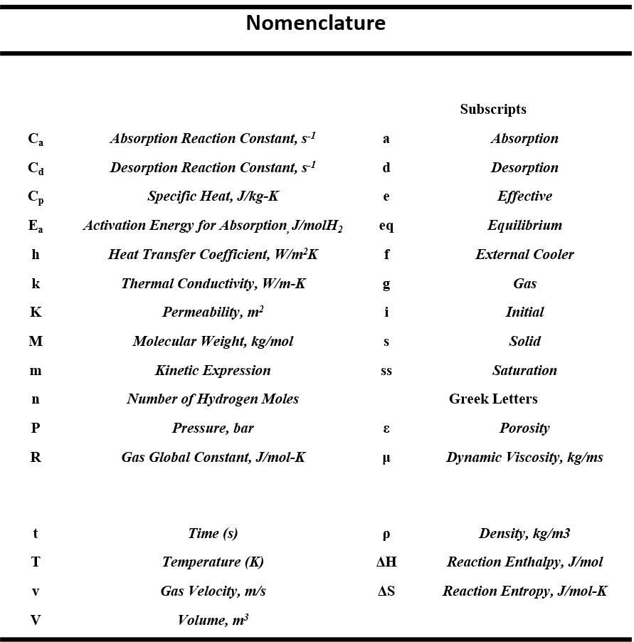

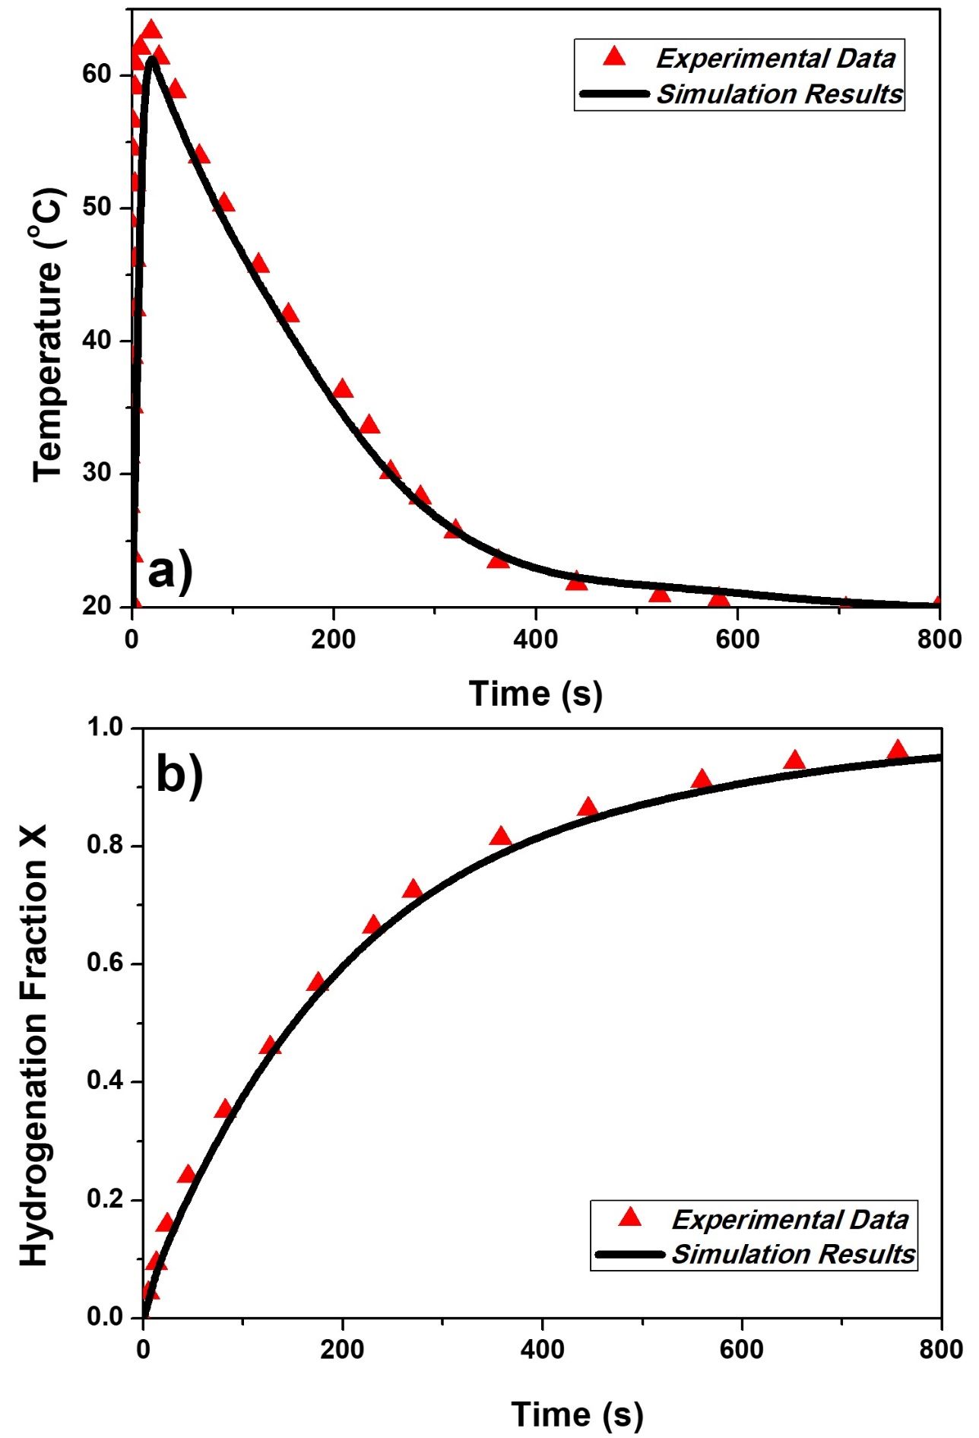

***Fig. 1. Comparison between the proposed numerical model and the experimental data. Fig. 1a shows the comparison between the temperature profile and Fig. 1b the comparison for the hydrogenation capacity***

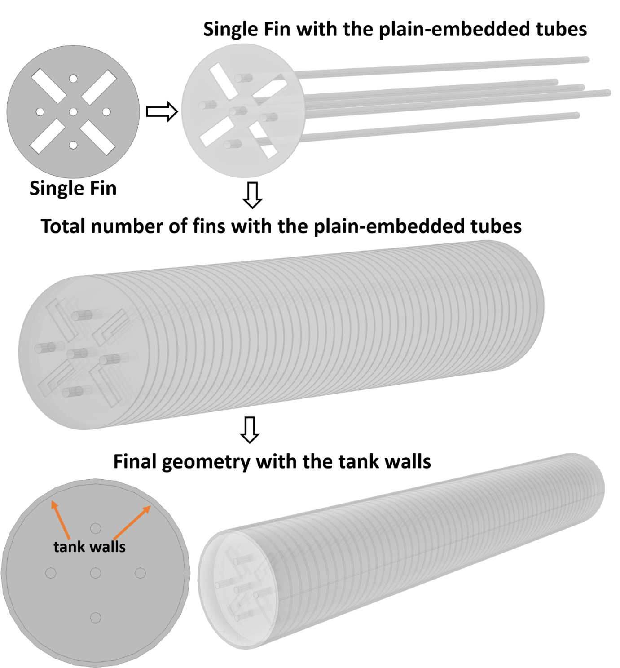

***Fig.2 Fin geometry (up) and the complete assembly of the fins, the cooling tubes and the complete metal hydride tank used in this study (down).***

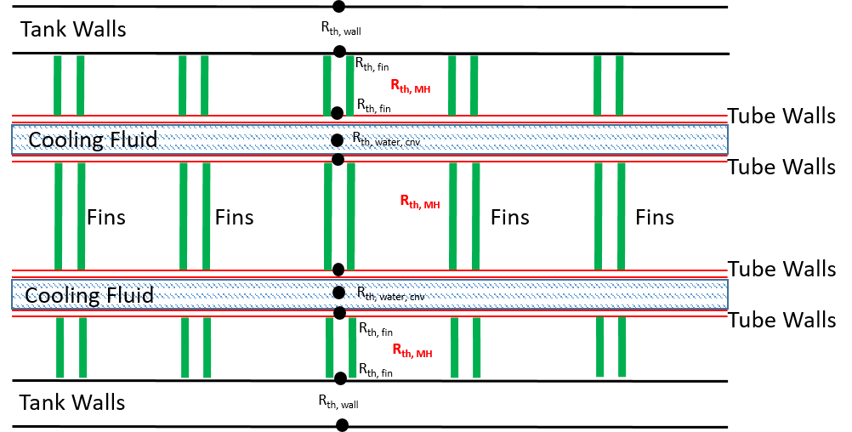***Fig. 3. Schematic of the resistance network used in the study***

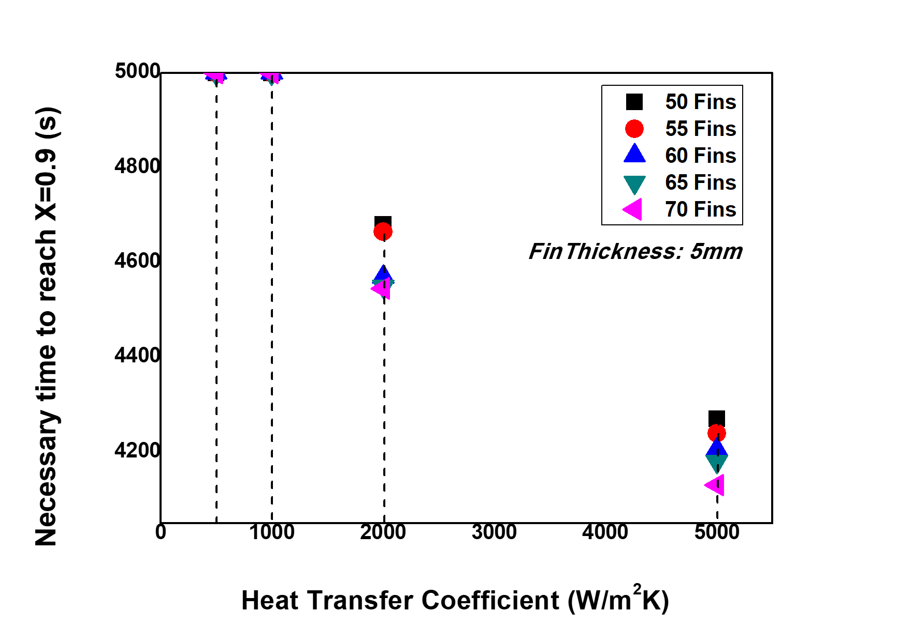

***Fig. 4.Time to reach X=0.9 against the values of the convective heat transfer coefficient, when the fin thickness is 5 mm and for all the values of fin number***

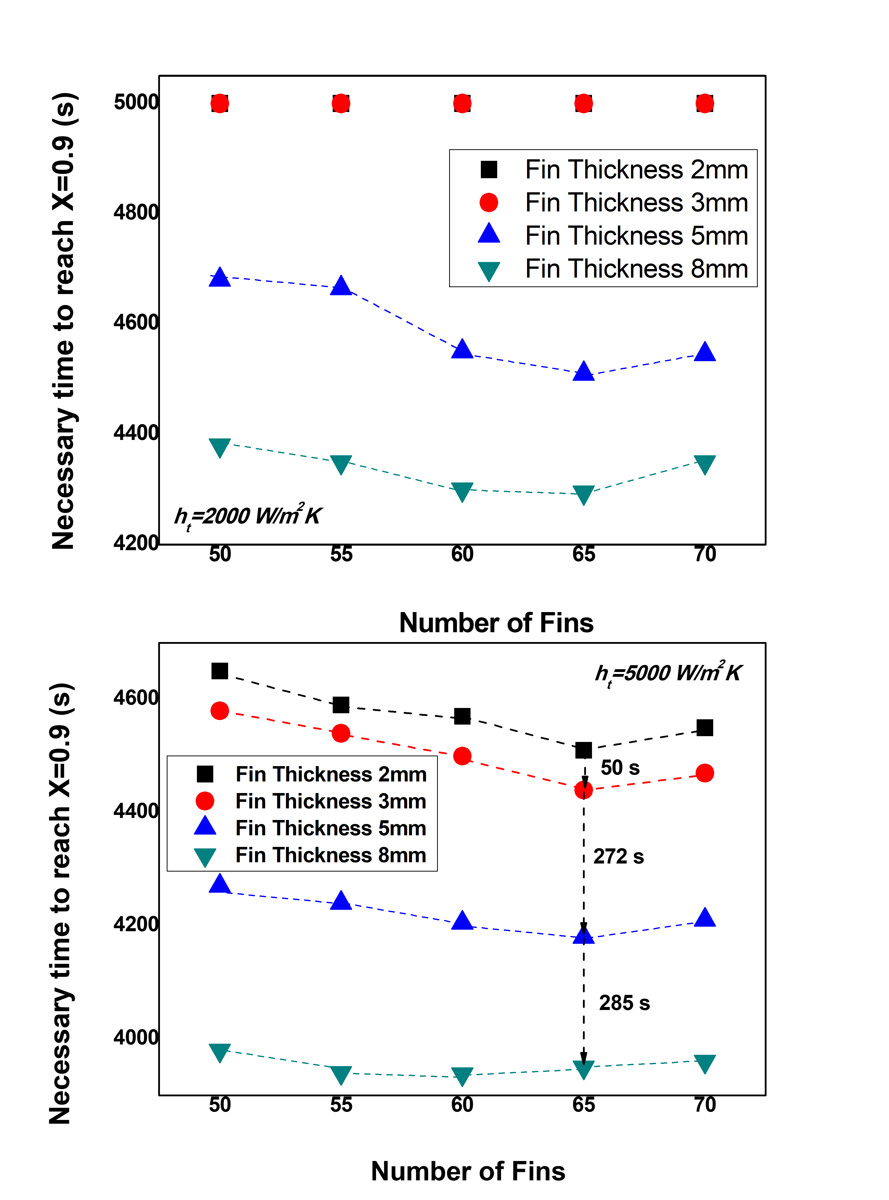

***Fig. 5. Hydrogen storage behaviour of the MmNi4.6Al0.4 for all the cases of fn and fth, when the ht is 2000 Wm-2K-1 (5a) and 5000 Wm-2K-1 (5b)***

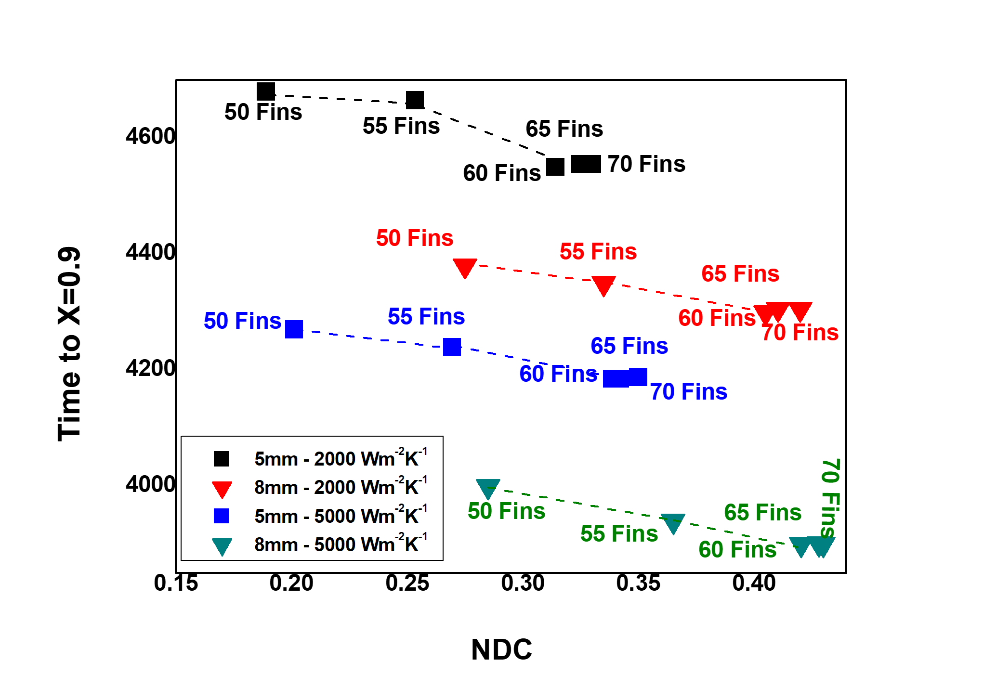

***Fig. 6. Hydrogenation behaviour of the metal hydride tank with the NDC for the following cases: fth=5 mm and ht=2000 W m-2K-1, fth=5 mm and ht =5000 W m-2K-1, fth=8 mm and ht=2000 W m-2K-1 and fth=8 mm and ht=5000 W m-2K-1***

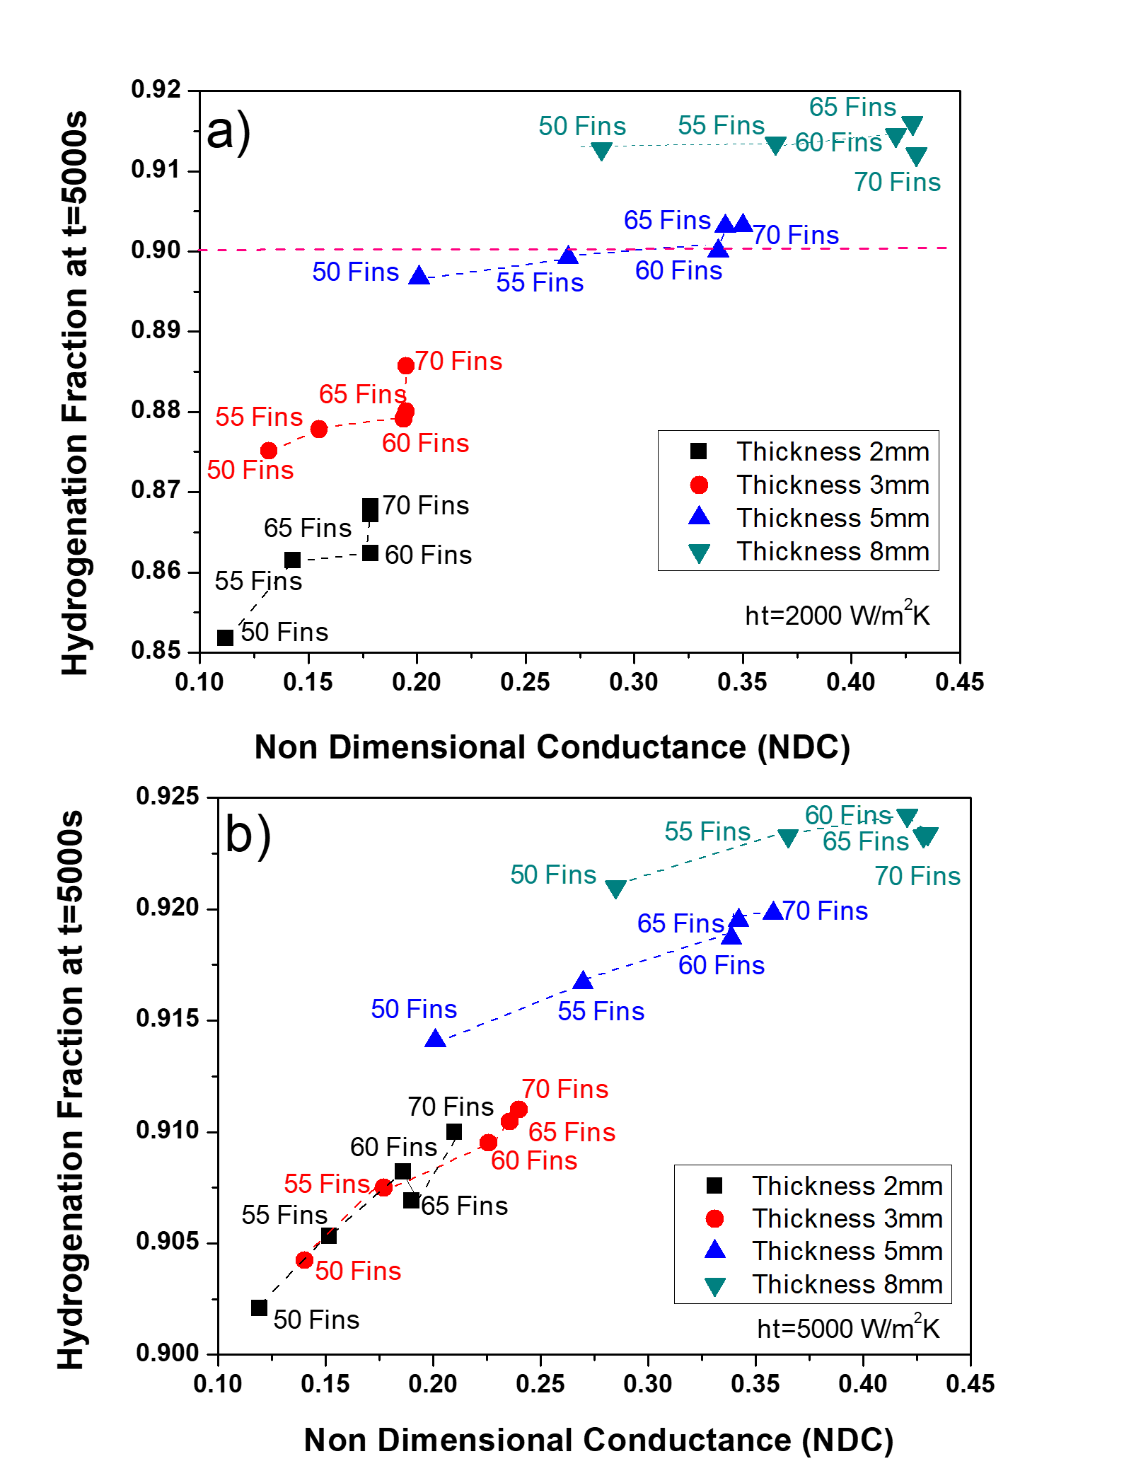***Fig. 7 Hydrogen quantity stored at the end of the desirable time frame (5000 s) against the NDC when ht= 2000 (7a) and 5000 (7b) Wm-2K-1***

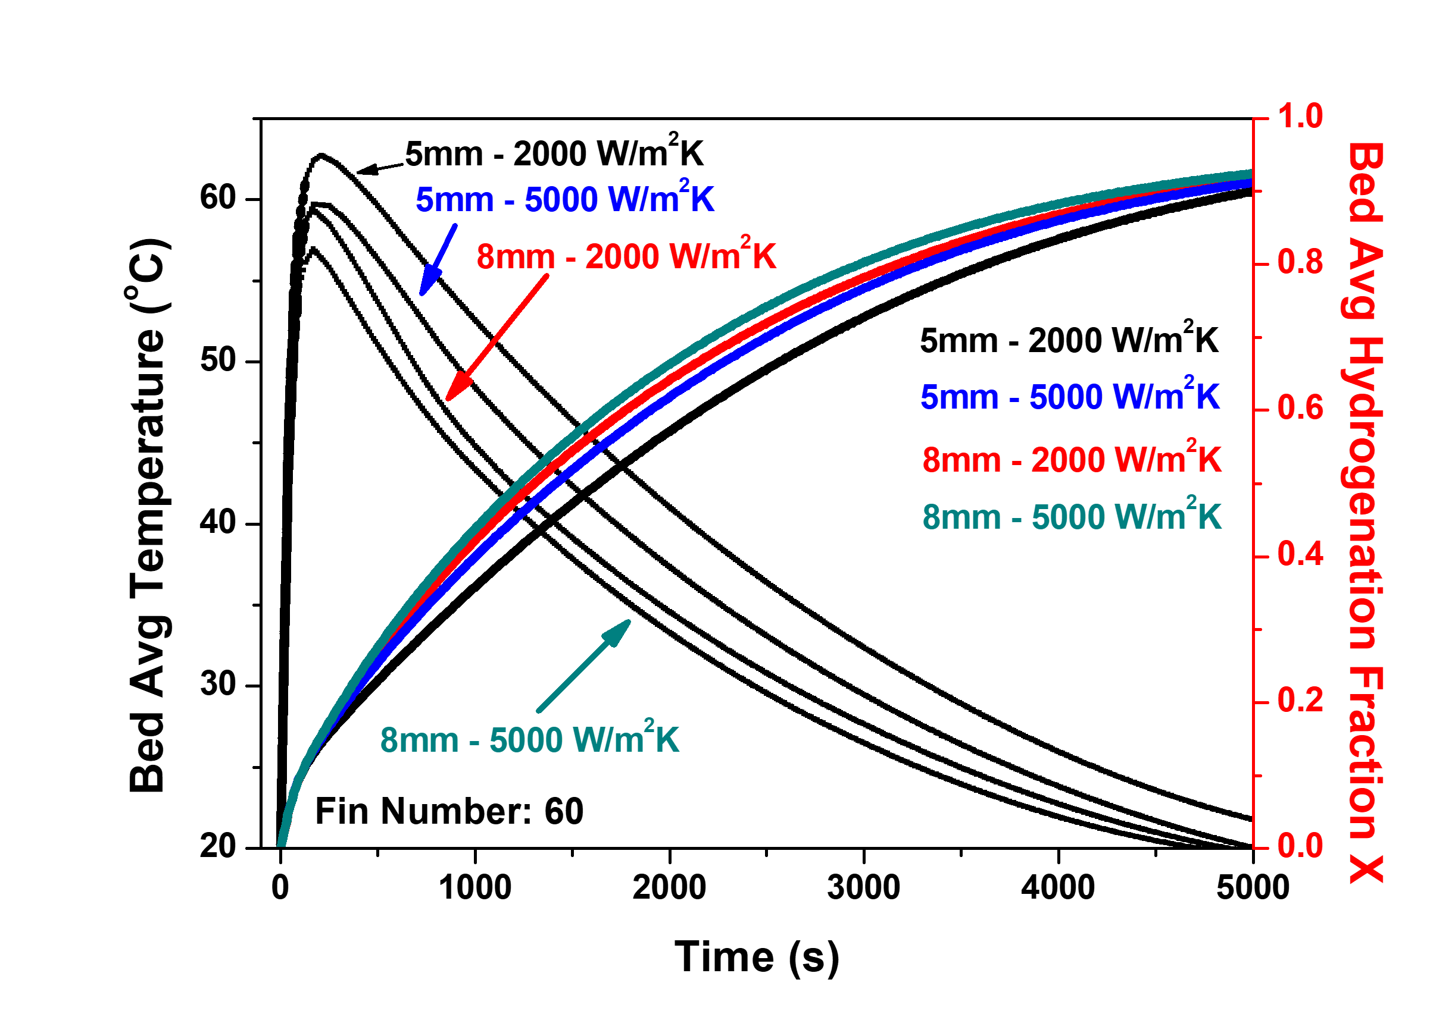

***Fig. 8. Hydrogen storage kinetics and temperature profile under the optimum operation conditions***

**References**

[1] Kamel E, Memari AM. Automated Building Energy Modelling and Assessment Tool (ABEMAT). Energy 2018;147:15–24. doi:https://doi.org/10.1016/j.energy.2018.01.023.

[2] International Energy Agency <https://www.iea.org/topics/energyefficiency/buildings/>

[3] Procedia Engineering 121 (2015) 645-652; Analysis of Carbon Dioxide Emissions of Buildings in Different Regions of China Based on STIRPAT Model

[4] S.A.A. Shazmin, I. Sipan, M. Sapri, H.M. Ali, F. Raji, Property tax assessment incentive for green building: Energy saving based-model, Energy. 122 (2017) 329–339. doi:https://doi.org/10.1016/j.energy.2016.12.078.

[5] F.H. Abanda, L. Byers, An investigation of the impact of building orientation on energy consumption in a domestic building using emerging BIM (Building Information Modelling), Energy. 97 (2016) 517–527. doi:https://doi.org/10.1016/j.energy.2015.12.135.

[6] U. Amin, M.J. Hossain, J. Lu, E. Fernandez, Performance analysis of an experimental smart building: Expectations and outcomes, Energy. 135 (2017) 740–753. doi:https://doi.org/10.1016/j.energy.2017.06.149.

[7] A. Bland, M. Khzouz, T. Statheros, E.I. Gkanas, PCMs for residential building applications: A short review focused on disadvantages and proposals for future development, Buildings. 7 (2017). doi:10.3390/buildings7030078.

[8] E.I. Gkanas, T.A. Steriotis, A.K. Stubos, P. Myler, S.S. Makridis, A complete transport validated model on a zeolite membrane for carbon dioxide permeance and capture, Appl. Therm. Eng. (2015). doi:10.1016/j.applthermaleng.2014.02.006.

[9] M. Gil-Báez, Á.B. Padura, M.M. Huelva, Passive actions in the building envelope to enhance sustainability of schools in a Mediterranean climate, Energy. (2018). doi:https://doi.org/10.1016/j.energy.2018.10.094.

[10] Cheng T-C, Cheng C-H, Huang Z-Z, Liao G-C. Development of an energy-saving module via combination of solar cells and thermoelectric coolers for green building applications. Energy 2011;36:133–40. doi:https://doi.org/10.1016/j.energy.2010.10.061.

[11] Bhowmik C, Bhowmik S, Ray A. Social acceptance of green energy determinants using principal component analysis. Energy 2018;160:1030–46. doi:https://doi.org/10.1016/j.energy.2018.07.093.

[12] Ben Chak-Man Leung, Greening existing buildings [GEB] strategies, Energy Reports, Volume 4, 2018, Pages 159-206, doi: <https://doi.org/10.1016/j.egyr.2018.01.003>.

[13] Sorgato MJ, Schneider K, Rüther R. Technical and economic evaluation of thin-film CdTe building-integrated photovoltaics (BIPV) replacing façade and rooftop materials in office buildings in a warm and sunny climate. Renew Energy 2018;118:84–98. doi:https://doi.org/10.1016/j.renene.2017.10.091.

[14] von Geibler J, Bienge K, Schüwer D, Berthold O, Dauensteiner A, Grinewitschus V, et al. Identifying business opportunities for green innovations: A quantitative foundation for accelerated micro-fuel cell diffusion in residential buildings. Energy Reports 2018;4:226–42. doi:https://doi.org/10.1016/j.egyr.2017.12.002.

[15] Murugan S, Horák B. A review of micro combined heat and power systems for residential applications. Renew Sustain Energy Rev 2016;64:144–62. doi:https://doi.org/10.1016/j.rser.2016.04.064.

[16] Budak Y, Devrim Y. Investigation of micro-combined heat and power application of PEM fuel cell systems. Energy Convers Manag 2018;160:486–94. doi:https://doi.org/10.1016/j.enconman.2018.01.077.

[17] Mamaghani AH, Najafi B, Casalegno A, Rinaldi F. Optimization of an HT-PEM fuel cell based residential micro combined heat and power system: A multi-objective approach. J Clean Prod 2018;180:126–38. doi:https://doi.org/10.1016/j.jclepro.2018.01.124.

[18] V. Taseska, N. Markovska, A. Causevski, T. Bosevski, J. Pop-Jordanov, Greenhouse gases (GHG) emissions reduction in a power system predominantly based on lignite, Energy. (2011). doi:10.1016/j.energy.2010.04.010.

[19] E.I. Gkanas, 5 - Metal hydrides: Modeling of metal hydrides to be operated in a fuel cell, in: P. Ferreira-Aparicio, A.M. Chaparro (Eds.), Portable Hydrog. Energy Syst., Academic Press, 2018: pp. 67–90. doi:https://doi.org/10.1016/B978-0-12-813128-2.00005-X.

[20] M. Khzouz, E.I. Gkanas, A. Girella, T. Statheros, C. Milanese, Sustainable hydrogen production via LiH hydrolysis for unmanned air vehicle (UAV) applications, Int. J. Hydrogen Energy. (2019). doi:https://doi.org/10.1016/j.ijhydene.2019.05.189.

[21] Y.E. Yuksel, M. Ozturk, I. Dincer, Thermodynamic analysis and assessment of a novel integrated geothermal energy-based system for hydrogen production and storage, Int. J. Hydrogen Energy. 43 (2018) 4233–4243. doi:https://doi.org/10.1016/j.ijhydene.2017.08.137.

[22] O. Siddiqui, I. Dincer, A novel hybrid ammonia fuel cell and thermal energy storage system, Int. J. Energy Res. 43 (2019) 3006–3010. doi:10.1002/er.4219.

[23]E.D. Koultoukis, E.I. Gkanas, S.S. Makridis, C.N. Christodoulou, D. Fruchart, A.K. Stubos, High-temperature activated AB2 nanopowders for metal hydride hydrogen compression, Int. J. Energy Res. (2014). doi:10.1002/er.3147.

[24] N.F. Attia, S.M. Lee, H.J. Kim, K.E. Geckeler, Nanoporous polypyrrole: preparation and hydrogen storage properties, Int. J. Energy Res. 38 (2014) 466–476. doi:10.1002/er.3095.

[24] E.I. Gkanas, T. Statheros, M. Khzouz, Heat management on rectangular metal hydride tanks for green building applications, Int. J. Hydrogen Energy. (2018). doi:https://doi.org/10.1016/j.ijhydene.2018.06.030.

[26] R. Halıcıoğlu, Ö.F. Selamet, M. Bayrak, Effects of reactor design on TiFe-hydride’s hydrogen storage, Int. J. Energy Res. 37 (2013) 698–705. doi:10.1002/er.2982.

[27] S.N. Nyamsi, M. Lototskyy, I. Tolj, Selection of metal hydrides-based thermal energy storage: Energy storage efficiency and density targets, Int. J. Hydrogen Energy. 43 (2018) 22568–22583. doi:https://doi.org/10.1016/j.ijhydene.2018.10.100.

[28] N. Bergemann, C. Pistidda, M. Uptmoor, C. Milanese, A. Santoru, T. Emmler, J. Puszkiel, M. Dornheim, T. Klassen, A new mutually destabilized reactive hydride system: LiBH4–Mg2NiH4, J. Energy Chem. 34 (2019) 240–254. doi:https://doi.org/10.1016/j.jechem.2019.03.011.

[29] E.I. Gkanas, M. Khzouz, Numerical analysis of candidate materials for multi-stage metal hydride hydrogen compression processes, Renew. Energy. 111 (2017). doi:10.1016/j.renene.2017.04.037.

[30] P. Muthukumar, A. Satheesh, M. Linder, R. Mertz, M. Groll, Studies on hydriding kinetics of some La-based metal hydride alloys, Int. J. Hydrogen Energy. 34 (2009) 7253–7262. doi:https://doi.org/10.1016/j.ijhydene.2009.06.075.

[31] Y. Zhang, D. Book, Hydrogen storage properties of ball-milled graphite with 0.5 wt% Fe, Int. J. Energy Res. 37 (2013) 720–725. doi:10.1002/er.1903.

[32] R. Halicioğlu, M. Bayrak, B. Işcan, F. Akbalik, An Experimental Study on Hydrogen Storage Capabilities Improvement of the TiFe-H2, Energy Sources, Part A Recover. Util. Environ. Eff. 34 (2012) 1876–1882. doi:10.1080/15567036.2010.487278.

[33] M. Ismail, Effect of LaCl3 addition on the hydrogen storage properties of MgH2, Energy. 79 (2015) 177–182. doi:https://doi.org/10.1016/j.energy.2014.11.001.

[34] C. Pistidda, N. Bergemann, J. Wurr, A. Rzeszutek, K.T. Møller, B.R.S. Hansen, S. Garroni, C. Horstmann, C. Milanese, A. Girella, O. Metz, K. Taube, T.R. Jensen, D. Thomas, H.P. Liermann, T. Klassen, M. Dornheim, Hydrogen storage systems from waste Mg alloys, J. Power Sources. 270 (2014) 554–563. doi:https://doi.org/10.1016/j.jpowsour.2014.07.129.

[35] G. Principi, F. Agresti, A. Maddalena, S. Lo Russo, The problem of solid state hydrogen storage, Energy. 34 (2009) 2087–2091. doi:https://doi.org/10.1016/j.energy.2008.08.027.

[36] A. Tokarev, A. V Avdeenkov, H. Langmi, D.G. Bessarabov, Modeling hydrogen storage in boron-substituted graphene decorated with potassium metal atoms, Int. J. Energy Res. 39 (2015) 524–528. doi:10.1002/er.3268.

[37] E.S. Kikkinides, M.C. Georgiadis, A.K. Stubos, Dynamic modelling and optimization of hydrogen storage in metal hydride beds, Energy. 31 (2006) 2428–2446. doi:https://doi.org/10.1016/j.energy.2005.10.036.

[38] V. Bérubé, G. Radtke, M. Dresselhaus, G. Chen, Size effects on the hydrogen storage properties of nanostructured metal hydrides: A review, Int. J. Energy Res. 31 (2007) 637–663. doi:10.1002/er.1284.

[39] E.I. Gkanas, D.M. Grant, M. Khzouz, A.D. Stuart, K. Manickam, G.S. Walker, Efficient hydrogen storage in up-scale metal hydride tanks as possible metal hydride compression agents equipped with aluminium extended surfaces, Int. J. Hydrogen Energy. 41 (2016). doi:10.1016/j.ijhydene.2016.04.035.

[40] B.A. Talagañis, G.O. Meyer, D.G. Oliva, M. Fuentes, P.A. Aguirre, Modeling and optimal design of cyclic processes for hydrogen purification using hydride-forming metals, Int. J. Hydrogen Energy. 39 (2014) 18997–19008. doi:https://doi.org/10.1016/j.ijhydene.2014.09.045.

[41] E.I. Gkanas, D.M. Grant, A.D. Stuart, C.N. Eastwick, D. Book, S. Nayebossadri, L. Pickering, G.S. Walker, Numerical study on a two-stage Metal Hydride Hydrogen Compression system, J. Alloys Compd. 645 (2015). doi:10.1016/j.jallcom.2015.03.123.

[42] S.S. Bhogilla, Design of a AB2-metal hydride cylindrical tank for renewable energy storage, J. Energy Storage. (2017). doi:10.1016/j.est.2017.10.012.

[43] M. Visaria, I. Mudawar, T. Pourpoint, S. Kumar, Study of heat transfer and kinetics parameters influencing the design of heat exchangers for hydrogen storage in high-pressure metal hydrides, Int. J. Heat Mass Transf. 53 (2010) 2229–2239. doi:https://doi.org/10.1016/j.ijheatmasstransfer.2009.12.010.

[44] E.I. Gkanas, M. Khzouz, G. Panagakos, T. Statheros, G. Mihalakakou, G.I. Siasos, G. Skodras, S.S. Makridis, Hydrogenation behavior in rectangular metal hydride tanks under effective heat management processes for green building applications, Energy. (2018). doi:10.1016/j.energy.2017.10.040.

[45] P. Muthukumar, M.P. Maiya, S.S. Murthy, Experiments on a metal hydride-based hydrogen storage device, Int. J. Hydrogen Energy. 30 (2005) 1569–1581. doi:https://doi.org/10.1016/j.ijhydene.2004.12.007.

[46] M. Raju, J.P. Ortmann, S. Kumar, System simulation model for high-pressure metal hydride hydrogen storage systems, Int. J. Hydrogen Energy. 35 (2010) 8742–8754. doi:https://doi.org/10.1016/j.ijhydene.2010.05.024.

[47] Perry HR, Green D. Perry’s chemical engineering handbook. 6th ed. McGraw Hill Publishers; 1984

[48] M. Raju, S. Kumar, Optimization of heat exchanger designs in metal hydride based hydrogen storage systems, Int. J. Hydrogen Energy. 37 (2012) 2767–2778. doi:https://doi.org/10.1016/j.ijhydene.2011.06.120.

[49] A. Singh, M.P. Maiya, S.S. Murthy, Effects of heat exchanger design on the performance of a solid state hydrogen storage device, Int. J. Hydrogen Energy. 40 (2015) 9733–9746. doi:https://doi.org/10.1016/j.ijhydene.2015.06.015.

[50] F. Askri, M. Ben Salah, A. Jemni, S. Ben Nasrallah, Optimization of hydrogen storage in metal-hydride tanks, Int. J. Hydrogen Energy. 34 (2009) 897–905. doi:https://doi.org/10.1016/j.ijhydene.2008.11.021.

[51] S. Anbarasu, P. Muthukumar, S.C. Mishra, Tests on LmNi4.91Sn0.15 based solid state hydrogen storage device with embedded cooling tubes – Part A: Absorption process, Int. J. Hydrogen Energy. 39 (2014) 3342–3351. doi:https://doi.org/10.1016/j.ijhydene.2013.12.090.

[52] A. Souahlia, H. Dhaou, F. Askri, S. Mellouli, A. Jemni, S. Ben Nasrallah, Experimental study and characterization of metal hydride containers, Int. J. Hydrogen Energy. 36 (2011) 4952–4957. doi:https://doi.org/10.1016/j.ijhydene.2011.01.074.

[53] J. Ma, Y. Wang, S. Shi, F. Yang, Z. Bao, Z. Zhang, Optimization of heat transfer device and analysis of heat & mass transfer on the finned multi-tubular metal hydride tank, Int. J. Hydrogen Energy. 39 (2014) 13583–13595. doi:https://doi.org/10.1016/j.ijhydene.2014.03.016.

[54] P. Muthukumar, A. Singhal, G.K. Bansal, Thermal modeling and performance analysis of industrial-scale metal hydride based hydrogen storage container, Int. J. Hydrogen Energy. 37 (2012) 14351–14364. doi:https://doi.org/10.1016/j.ijhydene.2012.07.010.

[55] H. Ben Mâad, F. Askri, S. Ben Nasrallah, Heat and mass transfer in a metal hydrogen reactor equipped with a phase-change heat-exchanger, Int. J. Therm. Sci. 99 (2016) 271–278. doi:https://doi.org/10.1016/j.ijthermalsci.2015.09.003.

[56] Z. Wu, F. Yang, L. Zhu, P. Feng, Z. Zhang, Y. Wang, Improvement in hydrogen desorption performances of magnesium based metal hydride reactor by incorporating helical coil heat exchanger, Int. J. Hydrogen Energy. 41 (2016) 16108–16121. doi:https://doi.org/10.1016/j.ijhydene.2016.04.224.

[57] F. Askri, M. Ben Salah, A. Jemni, S. Ben Nasrallah, Heat and mass transfer studies on metal-hydrogen reactor filled with MmNi4.6Fe0.4, Int. J. Hydrogen Energy. 34 (2009) 6705–6711. doi:https://doi.org/10.1016/j.ijhydene.2009.06.069.

[58] S. Mellouli, F. Askri, H. Dhaou, A. Jemni, S. Ben Nasrallah, Numerical simulation of heat and mass transfer in metal hydride hydrogen storage tanks for fuel cell vehicles, Int. J. Hydrogen Energy. 35 (2010) 1693–1705. doi:https://doi.org/10.1016/j.ijhydene.2009.12.052.

[59] B.D. MacDonald, A.M. Rowe, Impacts of external heat transfer enhancements on metal hydride storage tanks, Int. J. Hydrogen Energy. 31 (2006) 1721–1731. doi:https://doi.org/10.1016/j.ijhydene.2006.01.007.

[60] M. Afzal, P. Sharma, Design of a large-scale metal hydride based hydrogen storage reactor: Simulation and heat transfer optimization, Int. J. Hydrogen Energy. 43 (2018) 13356–13372. doi:https://doi.org/10.1016/j.ijhydene.2018.05.084.

[61] S.L. Garrison, B.J. Hardy, M.B. Gorbounov, D.A. Tamburello, C. Corgnale, B.A. vanHassel, D.A. Mosher, D.L. Anton, Optimization of internal heat exchangers for hydrogen storage tanks utilizing metal hydrides, Int. J. Hydrogen Energy. 37 (2012) 2850–2861. doi:https://doi.org/10.1016/j.ijhydene.2011.07.044.

[62] R. Halicioǧlu, Ö.F. Selamet, M. Bayrak, Effects of reactor design on TiFe-hydride’s hydrogen storage, Int. J. Energy Res. (2013). doi:10.1002/er.2982.

[63] S.N. Nyamsi, F. Yang, Z. Zhang, An optimization study on the finned tube heat exchanger used in hydride hydrogen storage system – analytical method and numerical simulation, Int. J. Hydrogen Energy. 37 (2012) 16078–16092. doi:https://doi.org/10.1016/j.ijhydene.2012.08.074.

[64] Tsotsas E, Martin H. Thermal conductivity of packed beds: a review. Chemical. Engineering and Processing: Process Intensification. 1987; 22:19-37.

[65] U. Mayer, M. Groll, W. Supper, Heat and mass transfer in metal hydride reaction beds: Experimental and theoretical results, J. Less Common Met. 131 (1987) 235–244. doi:https://doi.org/10.1016/0022-5088(87)90523-6.

[66] T. Nishizaki, K. Miyamoto, K. Yoshida, Coefficients of performance of hydride heat pumps, J. Less-Common Met. (1983). doi:10.1016/0022-5088(83)90372-7.

[67] K. Edalati, H. Shao, H. Emami, H. Iwaoka, E. Akiba, Z. Horita, Activation of titanium-vanadium alloy for hydrogen storage by introduction of nanograins and edge dislocations using high-pressure torsion, Int. J. Hydrogen Energy. 41 (2016) 8917–8924. doi:https://doi.org/10.1016/j.ijhydene.2016.03.146.

[68] T.R. BOTT, Fouling of Heat Exchangers, 1995. doi:10.1016/B978-044482186-7/50005-1.

[69] F.P. Incropera, D.P. DeWitt, T.L. Bergman, A.S. Lavine, Fundamentals of Heat and Mass Transfer 6th Edition, 2007. doi:10.1016/j.applthermaleng.2011.03.022.